WOODPECKER CNC Assembly instructions

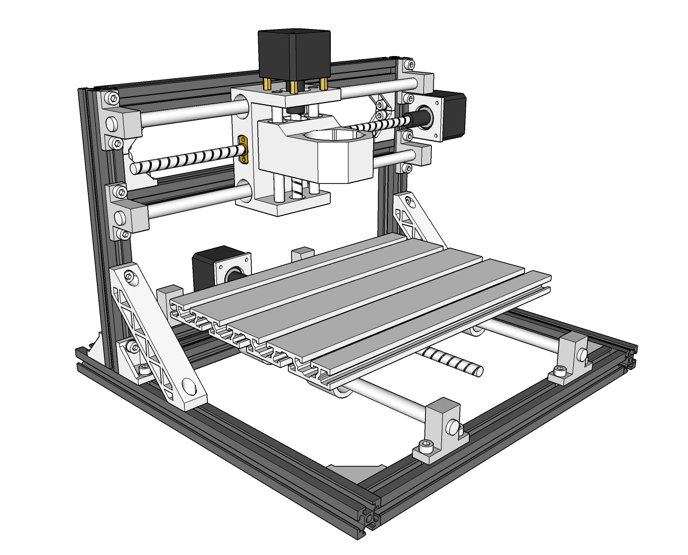
V2.5
- ·Component size：
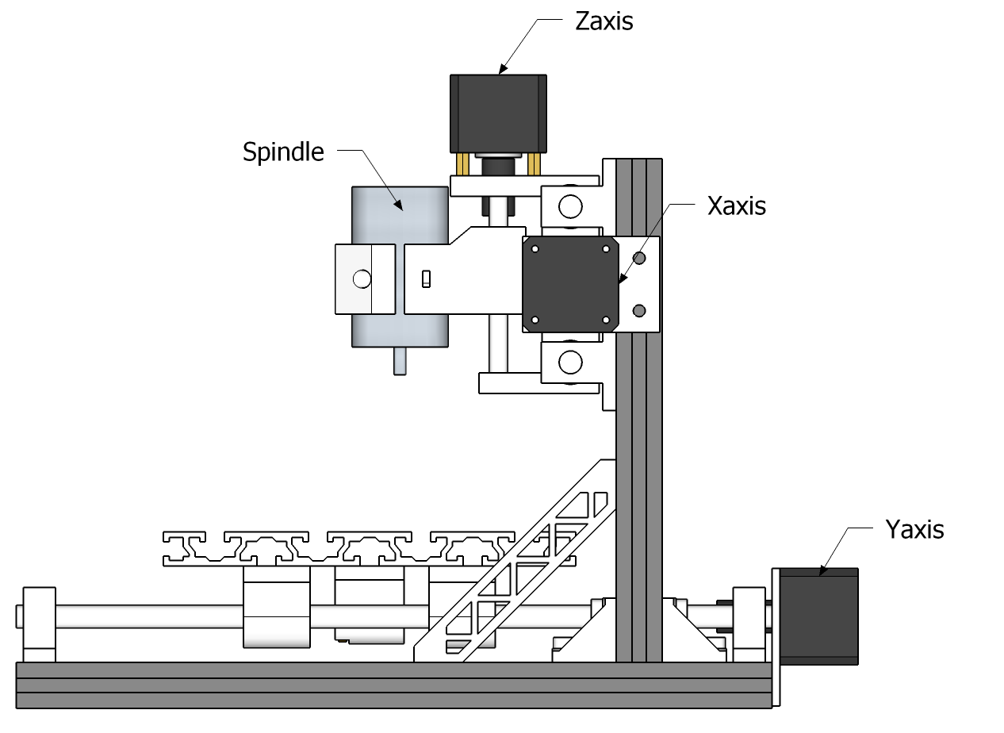

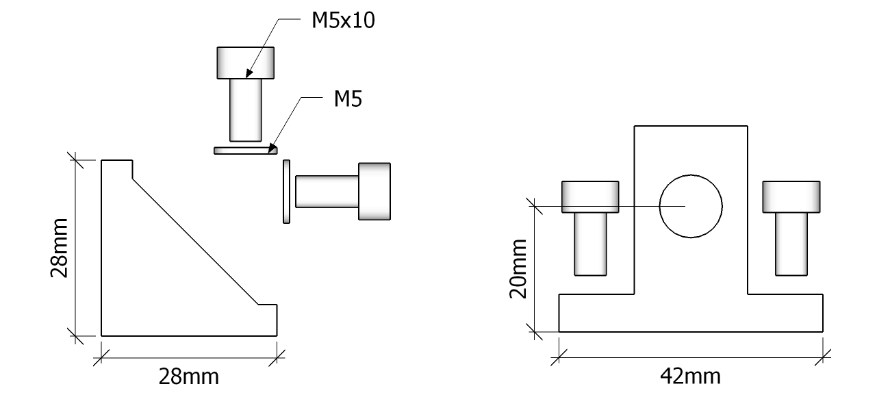
1. Frame installation
  - base：330mm×2、300mm×3、Corner pieces×6、M5*10×12、Spacer×12
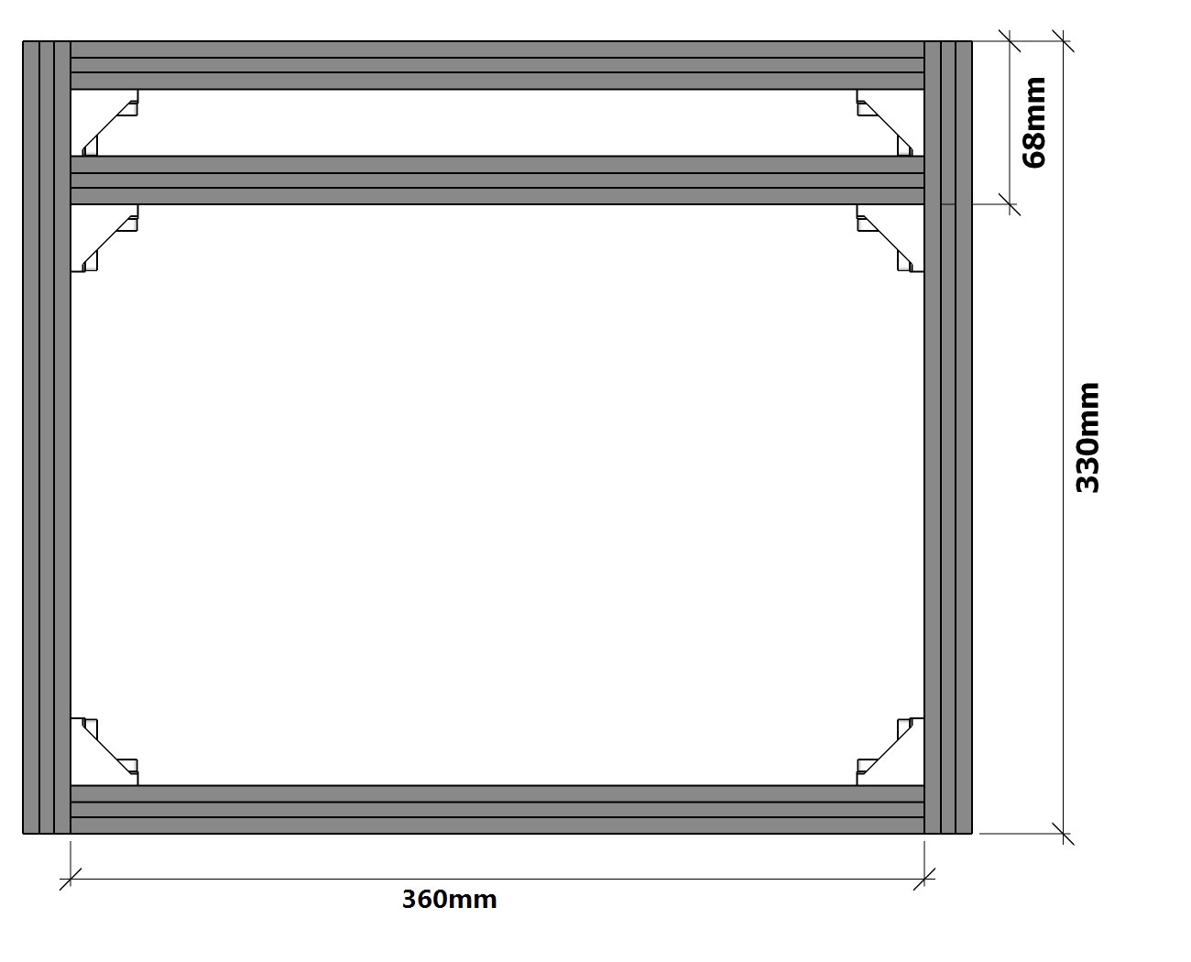
- Top frame：220mm×2、300mm×2、Corner pieces×4、M5*10×8、Spacer×8
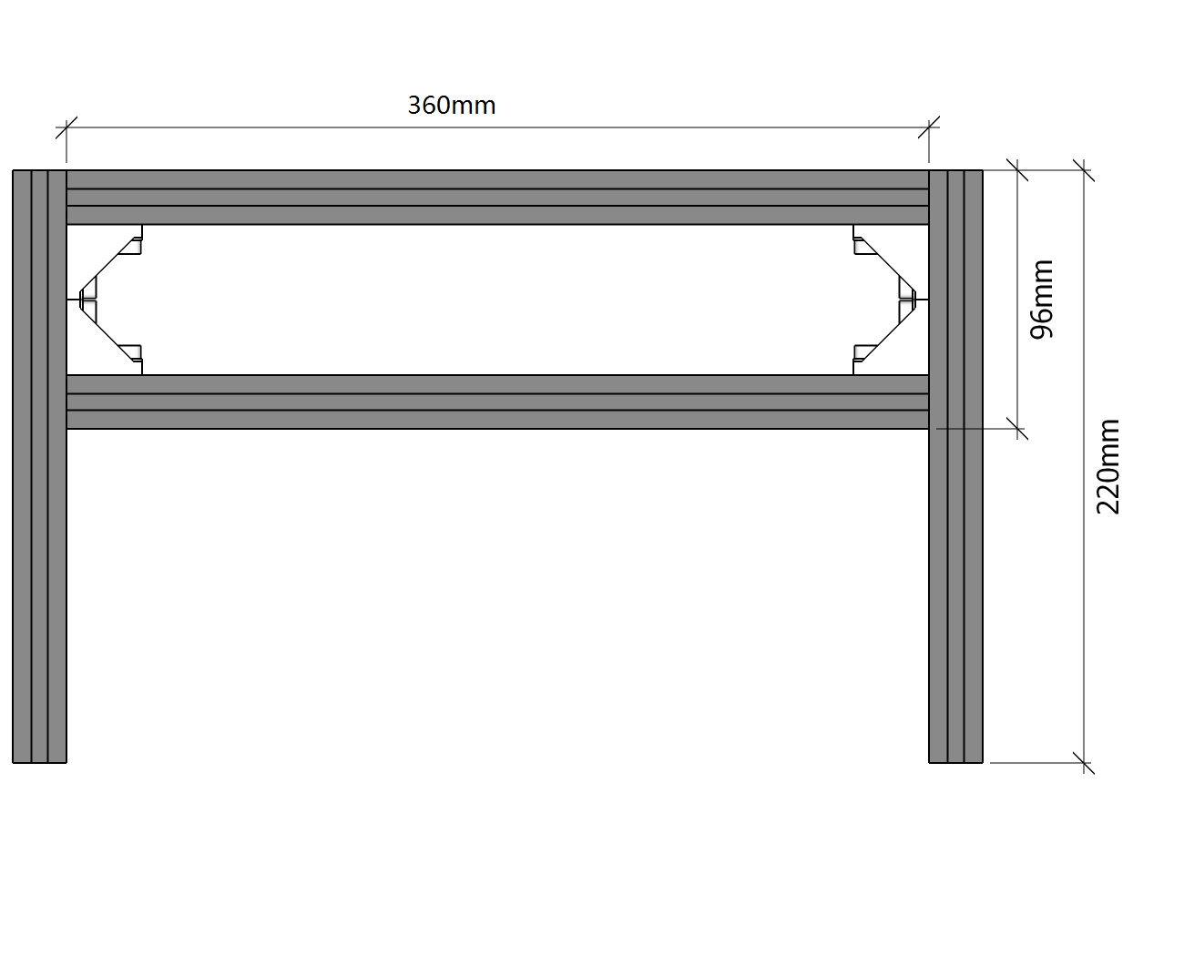
- Frame installation：Corner pieces×6、M5*10×16、Spacer×12、Connector×2
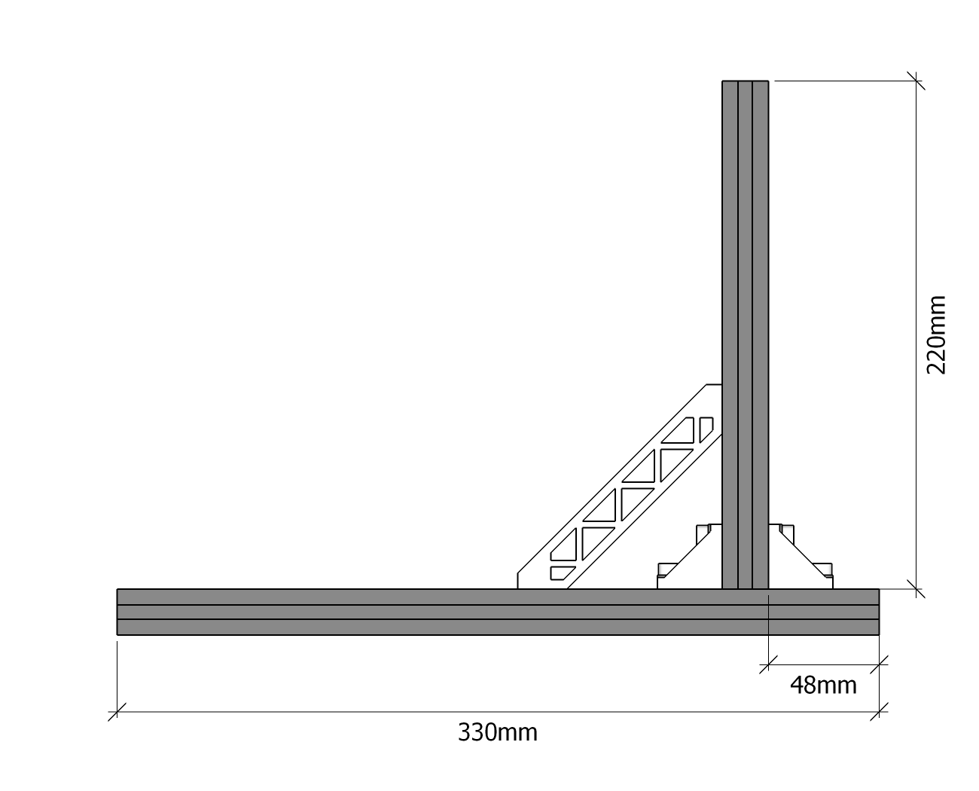
- axis support base dimensions 1：
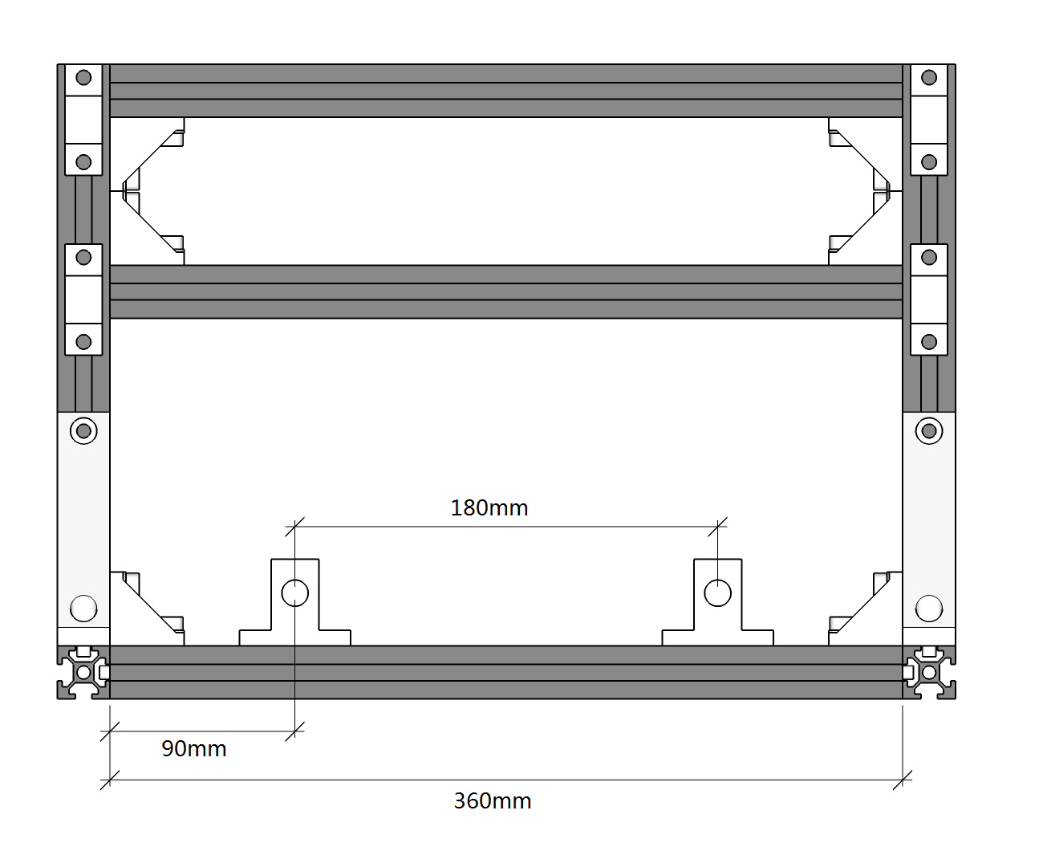
- axis support base dimensions 2：
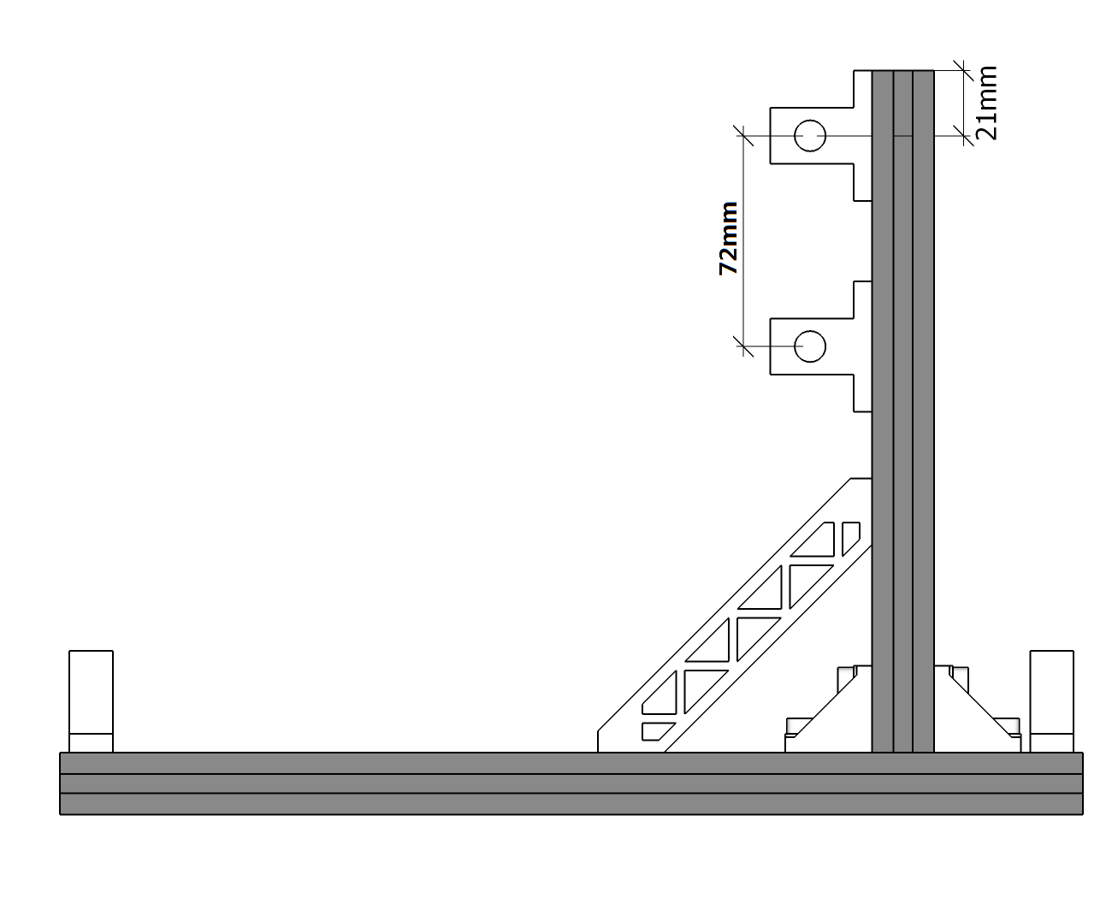
- Y-axis installation：M6*10×10、Slider×5、Mesa×1
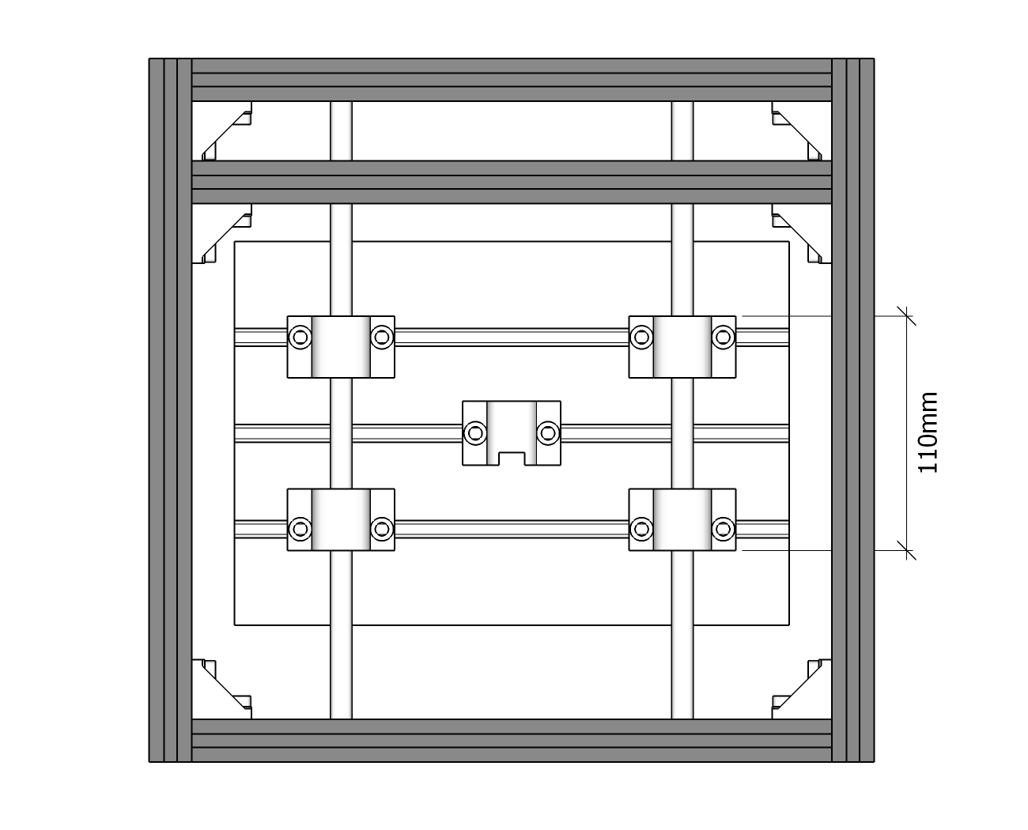
- stepper motor mounting
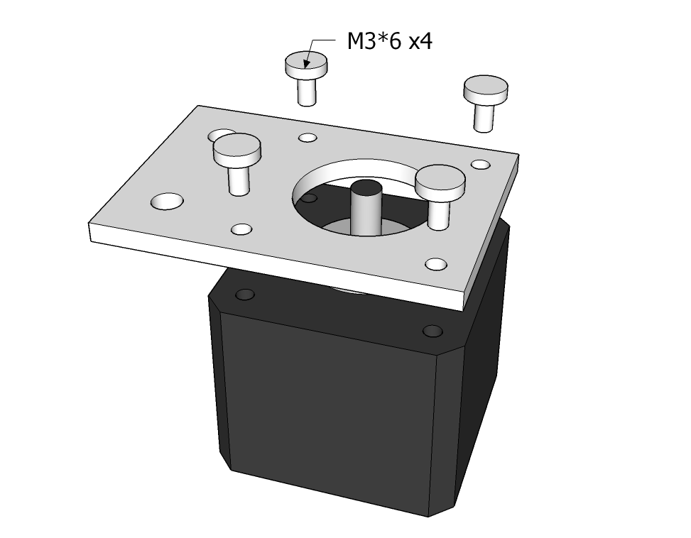
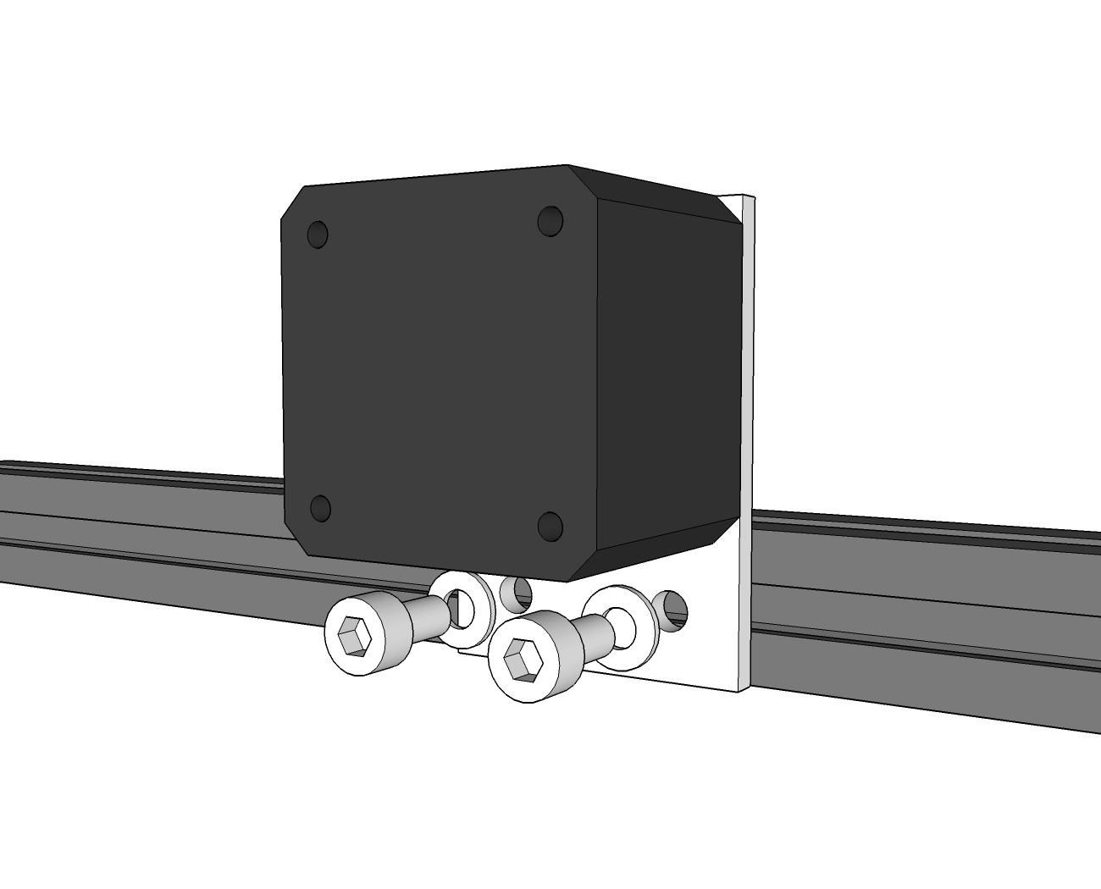
- XZ component installation
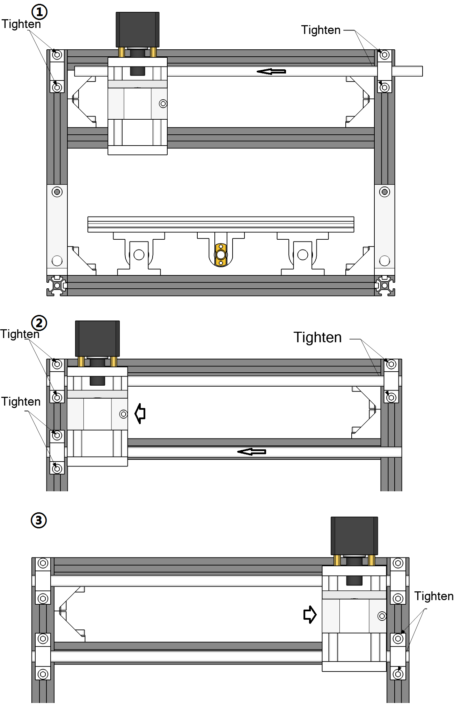
- screw assembly schematic
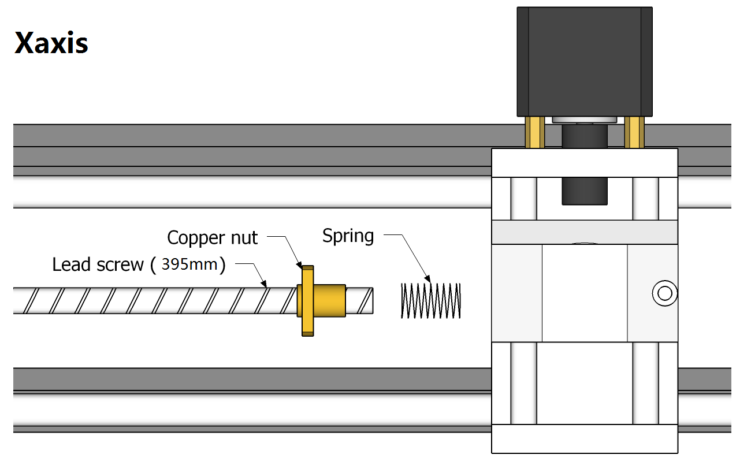
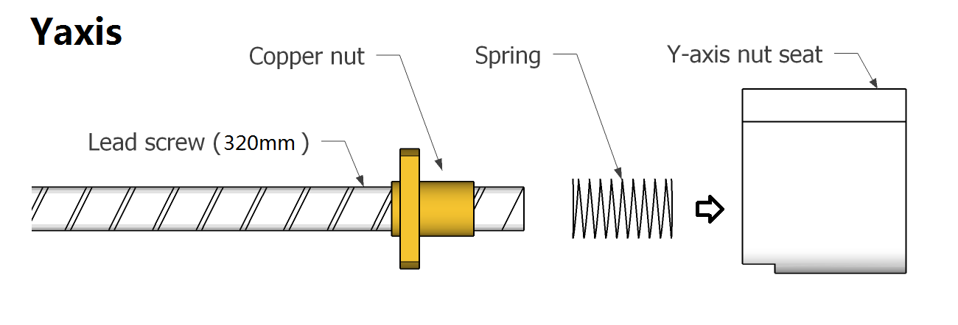
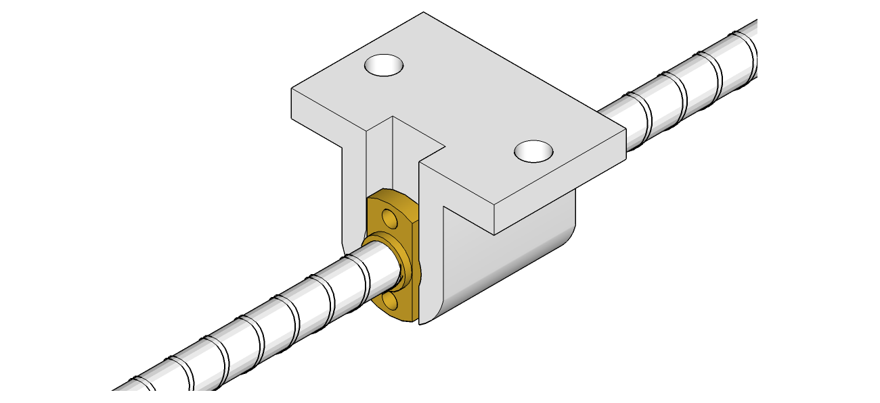
- Coupling assembly：
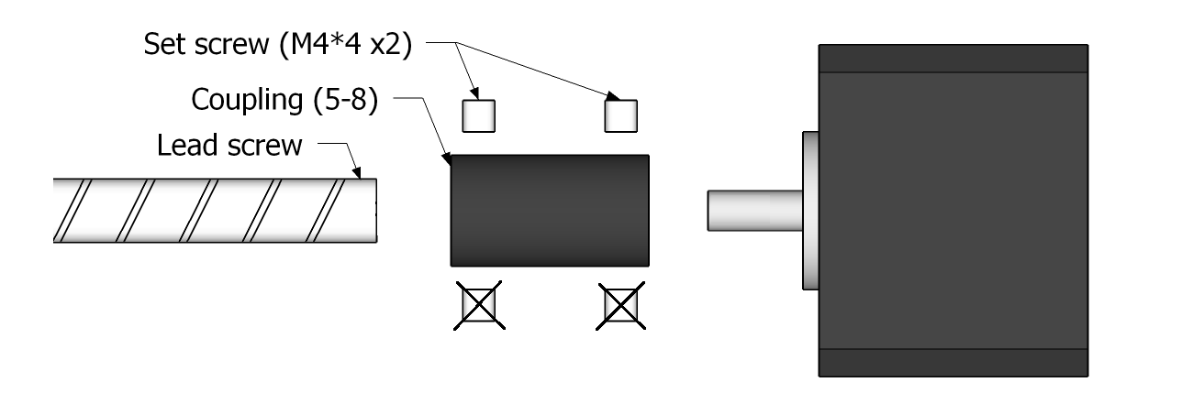
- Bearing installation：
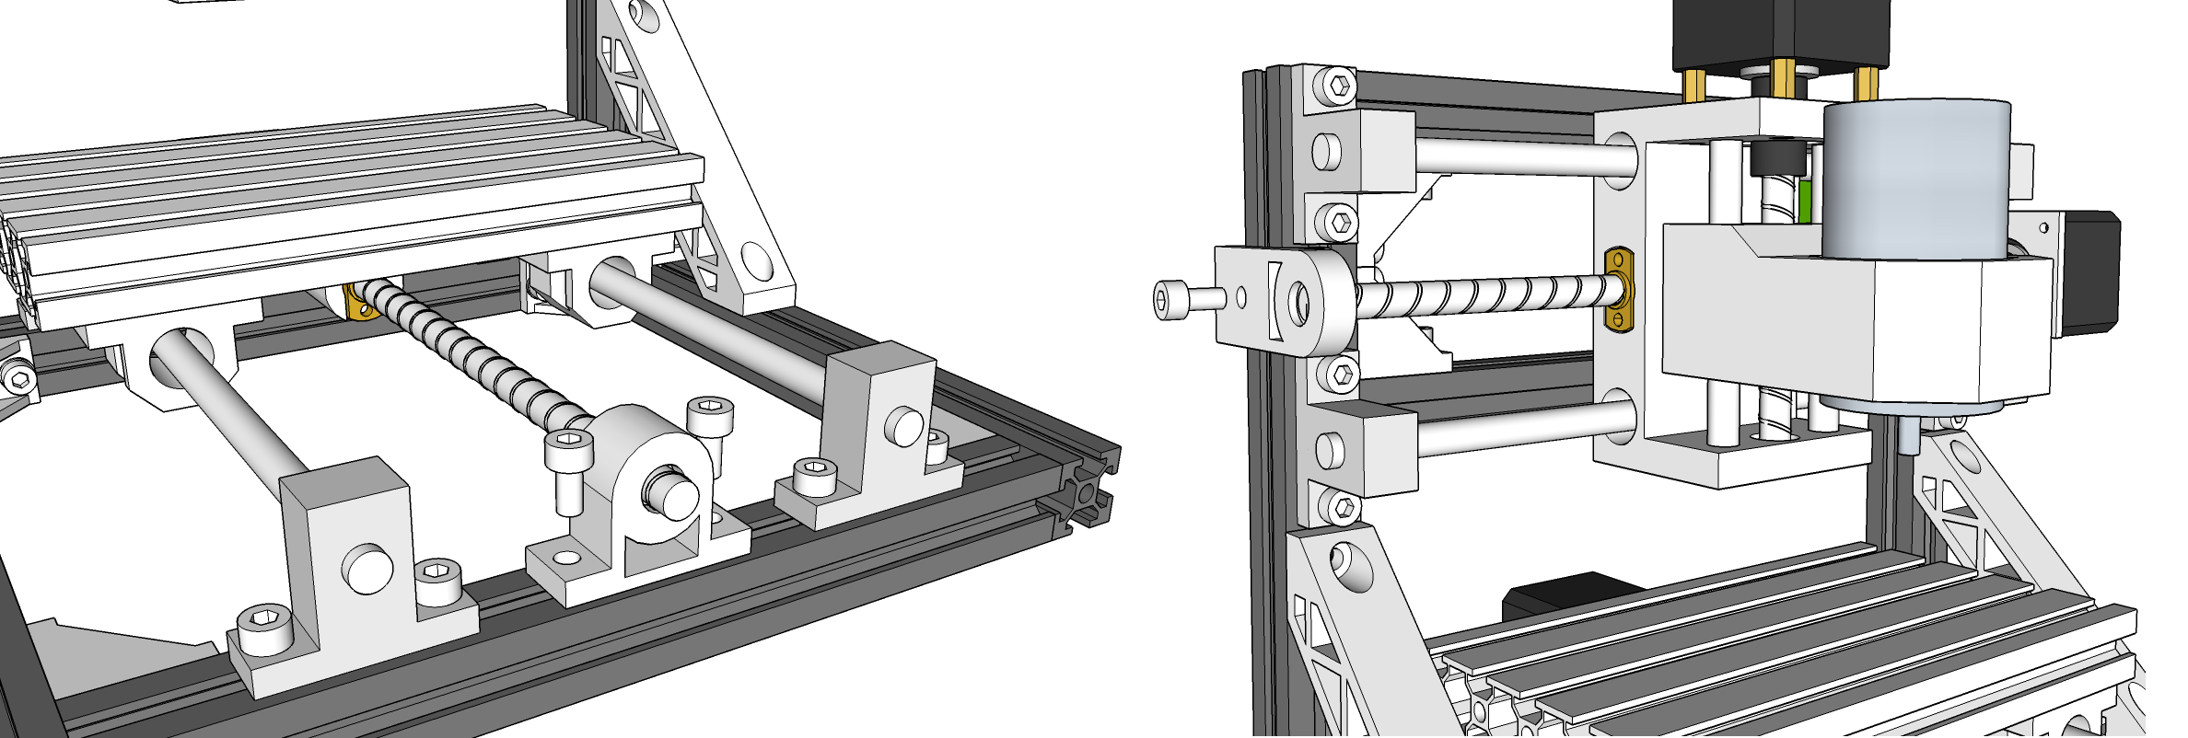
  - Install control board
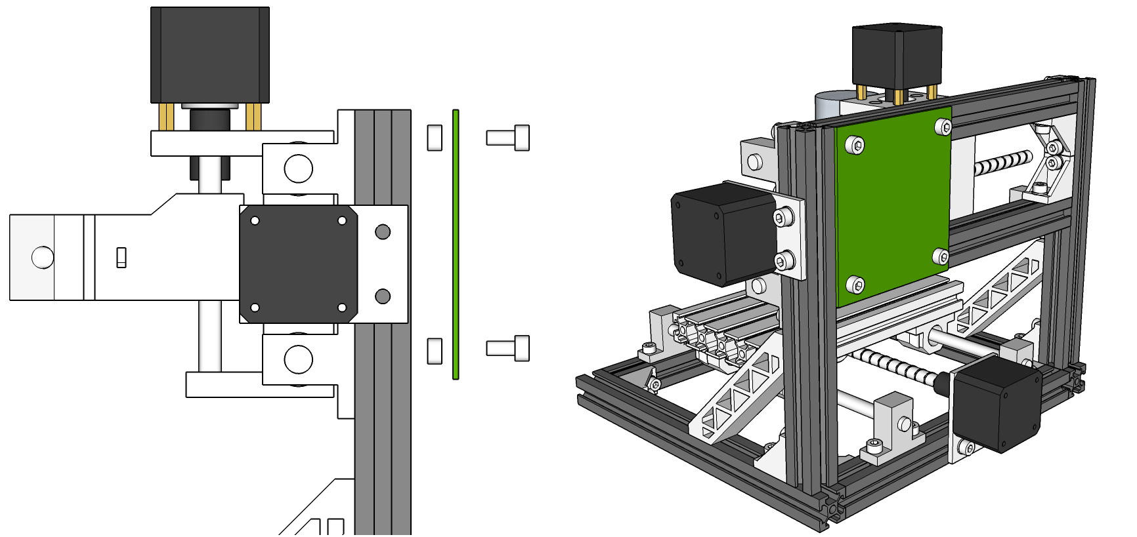
Wiring diagram:
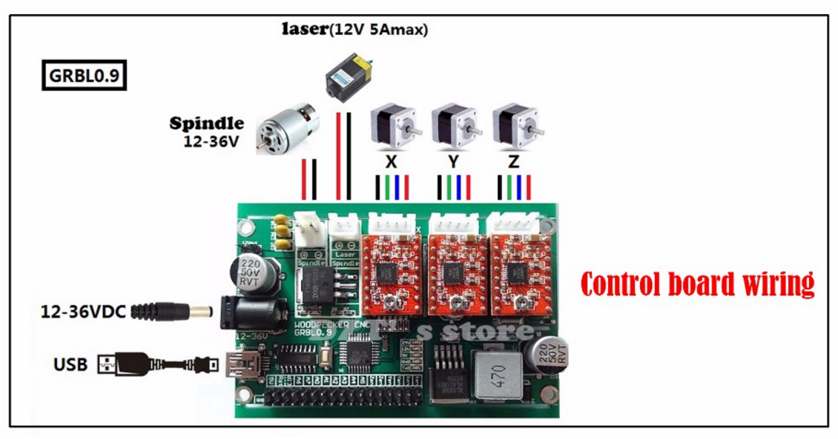

If you have any problems , please contact with us .
Our email address :

